**Machine learning**

**“Ability of computer to learn by itself”**

**Q1.For what purpose ml is used mainly?**

**Ans: ML is used for Prediction purposes with the best form of accuracy.**

**ML features**

**1.Supervised Learning**

**“It is defined by its use of labelled datasets to train algorithms that to classify data or predict outcomes accurately.”**

* **Classification:**   
  **“In machine learning, classification refers to a predictive modelling problem where a class label is predicted for a given example of input data.”**
* **Regression:**

**“Regression is a supervised machine learning technique which is used to predict continuous values.”**

**2.Unsupervised Learning**

**“unsupervised machine learning, uses machine learning algorithms to analyse and cluster unlabelled datasets.”**

* **Cluster:**

**“Clustering is the task of dividing the population or data points into a number of groups”**

**3.Reinforcement Learning**

“**Reinforcement learning is the training of machine learning models to make a sequence of decisions.”**

**Linear Regression**

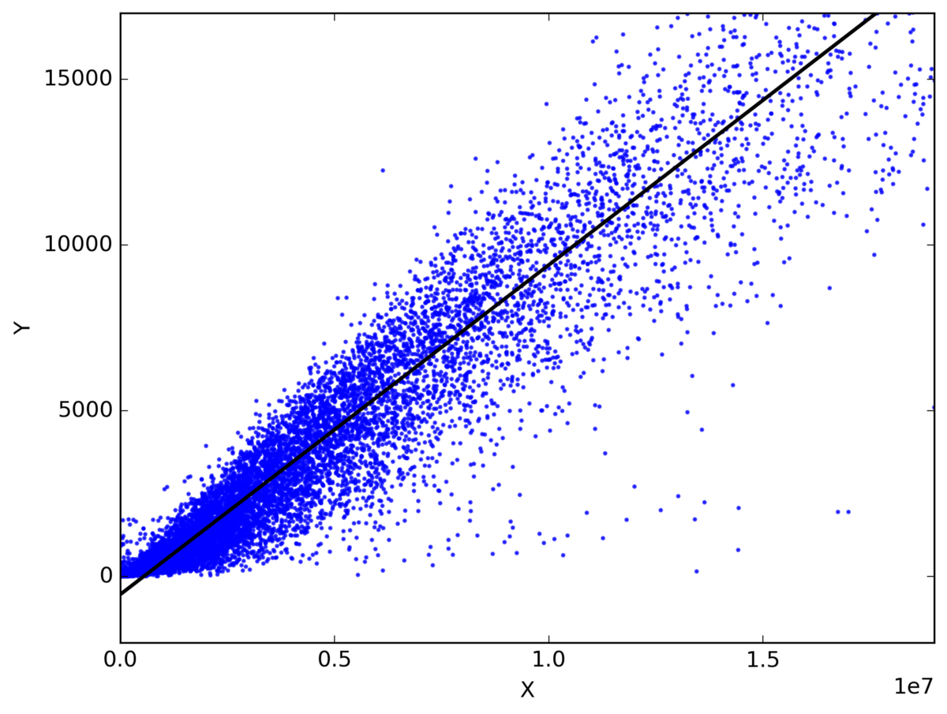

**Linear Regression is a supervised machine learning algorithm where the predicted output is continuous and has a constant slope. It's used to predict values within a continuous range, (e.g. sales, price) rather than trying to classify them into categories (e.g. cat, dog).**

**Equation**

**Y=bx+a**

**Y:prediction,b:slope of primary value**

**X:secondary value, a:value of y when x=0**

**logistic regression**

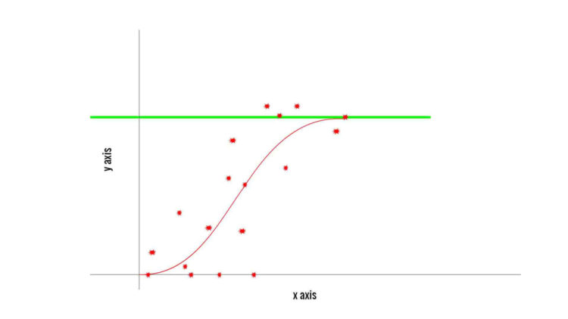

**“Logistic regression is a supervised learning classification algorithm used to predict the probability of a target variable. ... It is one of the simplest ML algorithms that can be used for various classification problems such as spam detection, Diabetes prediction, cancer detection etc.”**